NPG ADMS Upgrade – DNS/AD/MTLS/2FA

Configuration Notes – GE Internal Environment
CR169

Submitted by: | GE Vernova
Revision No. | 1.0
28 October, 2025


Table of Contents
1 Introduction 3
2 MTLS and Secure connection 3
2.1 MTLS for the replication group (NMS/report servers) 3
2.2 MTLS for the Windows machines – CallTaker 5
3 Common Instructions 5
3.1 SSL Certificates Generation 5

List of Figures

No table of figures entries found.

Introduction
This document is GE’s general technical configuration description based design document – “NPG ADMS Upgrade – DNS/AD/MTLS/2FA. General Design. CR169”.

MTLS and Secure connection

MTLS for the replication group (NMS/report servers)
There are following steps to be implemented for the configuration:
- Generating the certificates on the highest priority server of replication group (npgadmsnms1):
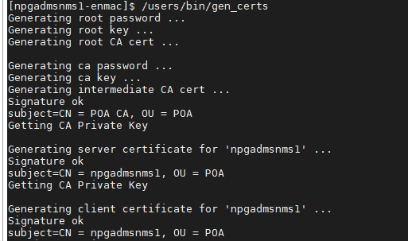

- Generating the certificates on other servers of replication group (npgadmsnms2), this must be run on the highest priority server (npgadmsnms1):
[npgadmsnms1-enmac]$ /users/bin/gen_certs -d 720 -t npgadmsnms2 > /tmp/npgadmsnms2.tar.gz
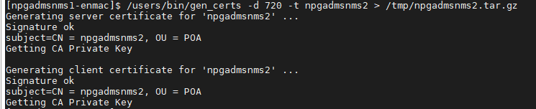
Use WinSCP to take the resulting tar.gz file from the highest priority server (npgadmsnms1) and transfer it to the appropriate lower priority server (npgadmsnms2).
Extract the tar.gz file to get the certs directory and move it to the /datafiles/config/ directory.
This must be done for all servers in the replication group, including reports servers.
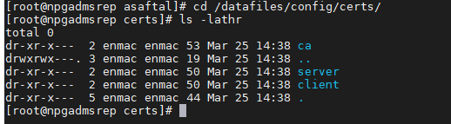

MTLS for the Windows machines – CallTaker
There are following steps to be implemented for the configuration:
- Generate certificates for the CT
On the priority server (npgadmsnms1), run the following command:
/users/bin/gen_certs -d 720 -z <CT_HOSTNAME> > ./certs.zip
- Create a folder for certificates on the CT (C:\CONFIG_DIR as an example).
- Copy the resulting certs.zip file to the CT and unzip it to the folder you created earlier.
- Import “ca/root.crt” to the Local Machine (Current User)/Trusted Root Certification Authorities.
- Import “ca/ca.crt” to the Local Machine (Current User)/Intermediate Certification Authorities
- Import “client/win.p12” to the Local Machine (Current User)/Personal
- Setup the environment variable POA_CONFIG_DIR to point to the certificates folder.
In the Command Line, “setx POA_CONFIG_DIR=<path\to\the\folder>”
- restart the server.

Common Instructions

SSL Certificates Generation

Customer Environment

Method 1
Step 1: Generate key for workstation

This step involves generating a private key for the workstation. The private key is used to sign a certificate signing request (CSR) and to encrypt/decrypt data.
Command:
openssl genrsa -out workstation.key 2048
- workstation.key: Output private key file.
- 2048: Key size (can also be 4096 for stronger security).

Step 2: Generate sign request for workstation

Using the private key, generate a Certificate Signing Request (CSR). This request will be sent to the customer (or their CA) for signing.
Command:
openssl req -new -key workstation.key -out workstation.csr \
-subj "/C=UK/ST=State/L=City/O=Org/OU=IT/CN=workstation.example.com"

- Replace the -subj values with appropriate details.
- workstation.csr: The file you'll send to the customer.

Step 3: Request customer to sign and generate certificate for workstation

- Send the workstation.csr file to the customer.
- They will use their internal Certificate Authority (CA) to sign it and issue a certificate.
- The result will be a signed certificate, often in .crt or .pem format.

Step 4: Customer provides back workstation certificate, intermediate CA certs, and root CA certificate

The customer will send:
- workstation.crt or workstation.pem (signed certificate)
- intermediate1.crt, intermediate2.crt, ... (intermediate CA certificates)
- rootCA.crt (root CA certificate)

Method 2
This method is to avoid using openssl and only performing certificate generation using keytool if openssl is not available.
Step 1: Generate key + keystore for workstation

Command:
keytool -genkeypair \
-alias client-alias \
-keyalg RSA \
-keysize 2048 \
-keystore client-keystore.p12 \
-storetype PKCS12 \
-dname "CN=workstation.example.com, OU=IT, O=Org, L=City, ST=State, C=UK"

Step 2: Generate sign request for workstation

Generate CSR:
Command:
keytool -certreq \
-alias client-alias \
-keystore client-keystore.p12 \
-file client.csr

Step 3: Request customer to sign and generate certificate for workstation
Step 4: Customer provides back workstation certificate, intermediate CA certs, and root CA certificate

